Meet the Governors

David Gordon – Chair of Governors
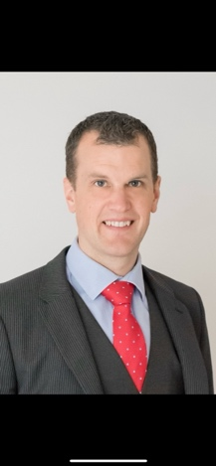
I am foundation governor who joined the governing board in November 2021. My son a pupil at St Helens. I am currently chair of the board and also sit on the finance and staffing committee. Outside of governors I work in financial services running a digital banking team and in my spare time I’m and avid cricket fan and cyclist.

Charlie De Nobriga – Vice Chair of Governors
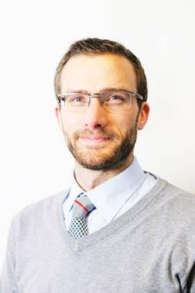
I am a Foundation Governor of The Federation of St. Helen's and St. Mary's and current Vice Chair of Governors. I was previously a Foundation Governor with St. Mary's Primary School in Yate since autumn 2013. In 2018 I was elected as Chair of Governors, a role I filled until the dissolution of that board and the formation of the new Federation governing body. I have had roles across multiple sub-committees of the governing body, as well as being part of small teams focussed on recruitment and strategy. Being a governor is a hugely fulfilling role for me, and I take great enjoyment in volunteering my skills in support of our two schools

Julie Simpson – Executive Head

I have been a school leader for over 20 years and my experience ranges from maintained schools to working in Multi Academy Trusts in Cornwall and Dorset. I moved back to my hometown of Bristol in 2023 to become the Executive Head Teacher of the Federation of St Helen's and St Mary's. It is a privilege to work with the dedicated and committed staff of the two schools who provide such a broad and exciting educational experience for our children.
Kelly Reed - Parent Governor
I live locally with my husband, our two boys and Izzy the dog. The boys are currently in year 5 and year 2 at St. Mary's. I work in Learning and Development for an engineering firm, moving across from my previous role as an engineer to run the early careers programme. With my role in learning, children at the school and having been to St. Mary's myself I was keen to find a way to support the school and local community so I became a parent governor. As a member of the board, I work with the other governors and the school leadership to drive improvement. I am passionate about inclusivity and improving outcomes for all children.

Ben Fowkes – Parent Governor
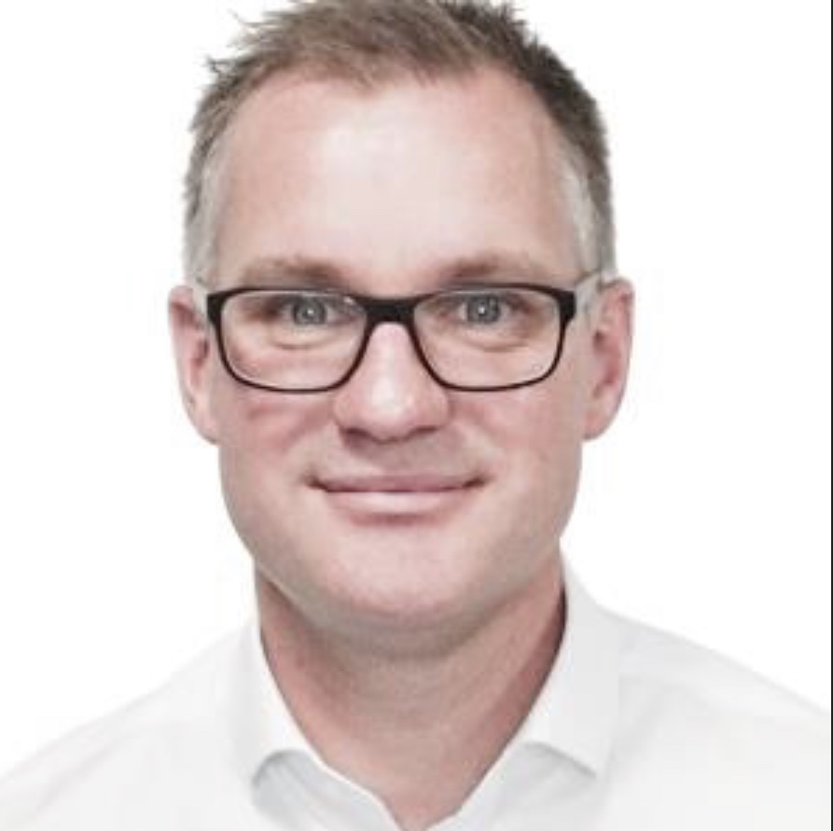

I am married with two children, both of our children currently at St Helens. We’ve lived Alveston for 7 years, having relocated from central Bristol. My professional background began with an apprenticeship in Engineering, followed by a late enrolment to university in my early 20’s. Having exited University, I have worked across a diverse set of sectors such as Defence, Aerospace, Manufacturing and Finance. I have run own consultancy business for 8 years, which offers transferrable skills into the parent governor role, such as finance management, strategic planning, compliance, and human resources. I have a keen interest in the workings of the schools, and an appetite to learn new skills from a sector which is unfamiliar, but deeply important to my family. The parent governor is a position I feel requires energy, commitment, and enthusiasm and along with being ready to learn new skills. I very much look forward to supporting and developing The Federation St Helens and St Mary’s further.

David Moss – Foundation Governor
I am David, the Vicar and exoficio governor of St. Helen’s, Alveston and now the Federation. I am married to Sue with five children. The youngest attends the local Secondary School, Marlwood. When not in the parish you will find me in the garden with the chickens, out and about with the dog, or tinkering with my classic Morris Minor in the garage. We love family camping holidays, our favourite place is St. Agnes, Isles of Scilly.

Joanne Hodge – Foundation Governor
I am known as Reverend Jo in school, and I am an Associate Minister in Yate Parish; my particular area of responsibility is Pastoral Care. I enjoy being a member of the team that leads the Collective Worship at St Mary's on Thursdays, am a Foundation Governor and I'm also a Transforming Lives for Good coach at St Mary's School. I am known as Reverend Jo in school, and I am an Associate Minister in Yate Parish; my particular area of responsibility is Pastoral Care. I enjoy being a member of the team that leads the Collective Worship at St Mary's on Thursdays, am a Foundation Governor and I'm also a Transforming Lives for Good coach at St Mary's School.

Fiona Kitson – Staff Governor
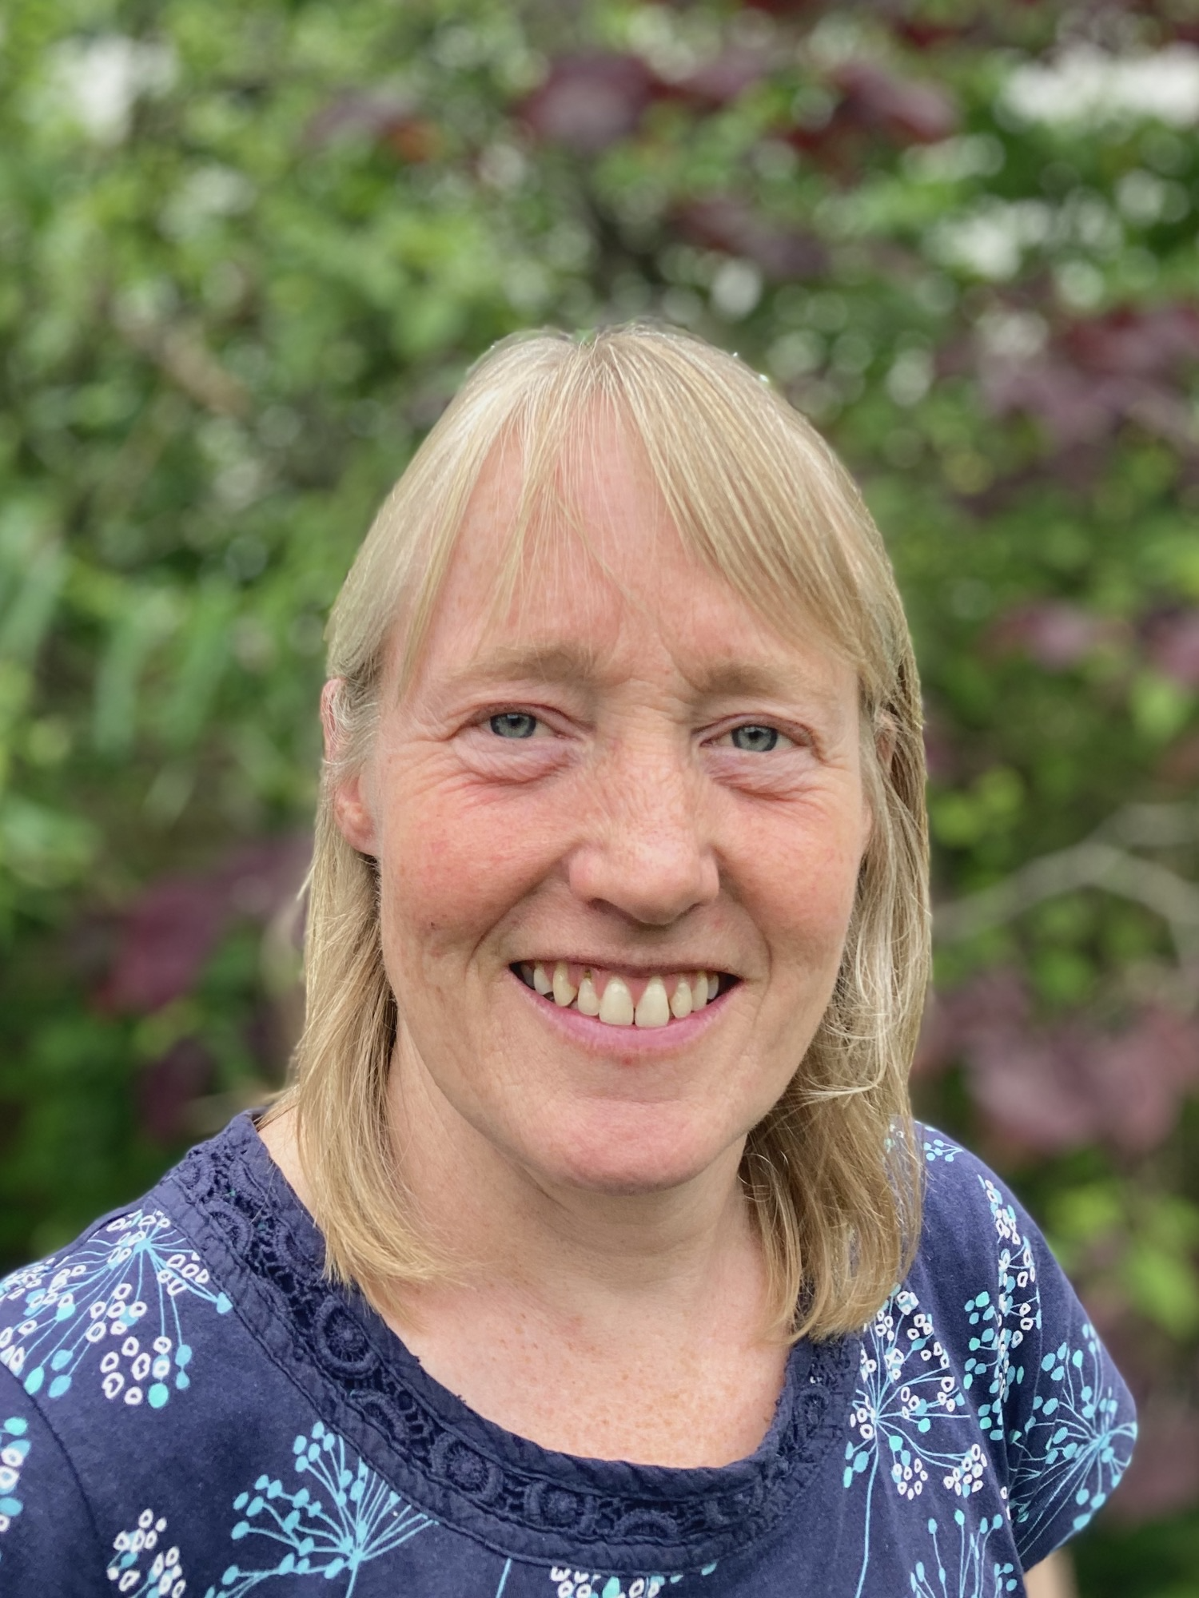
Hi, my name is Fiona Kitson and I'm the staff governor for the federation and also chair of the curriculum and standards committee. I've worked as a teaching assistant at St Helen's for 10 years and I'm currently based in the Reception class, where I also teach RE and outdoor learning

Hannah Peacock – Foundation Governor

I am a Foundation Governor who joined the governing body in July 2024. I was a pupil at St Mary's School in the 90s, so I have had a strong connection with the school since I was a child and my daughter is now a pupil there herself. I work as an Ofsted Registered Childminder, and have a strong passion for support children's growth and development. Outside of work, I have a love for musical theatre! I am a member of a theatre company, and I also help run and choreograph for a Youth Theatre Company.

Neil Ayliffe – Co opted Governor
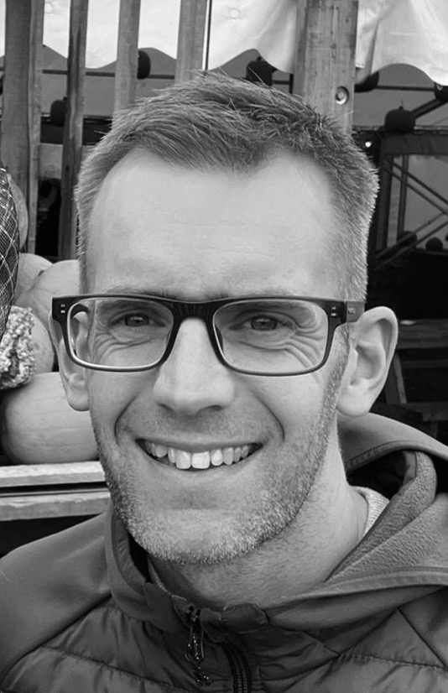
I am a co-opted governor who joined the governing board in March 2024 and I have two daughters currently enjoying their time at St Helen's. My career has revolved around working in Product Management across the financial services industry. Currently working in Wealth Management, but I've also worked across banking, insurance and in the FinTech space. I look forward to bringing the experience and transferable skills that I've developed to the Governing board, complementing the skills and experience of my fellow governors and certainly learning from them. Outside of work I can often be found running around the South Gloucestershire countryside, doing a bootcamp session or supporting or playing football.

